4TH JUNE, 2026

MONGODB CRUD OPERATIONS - UNSET OPERATOR
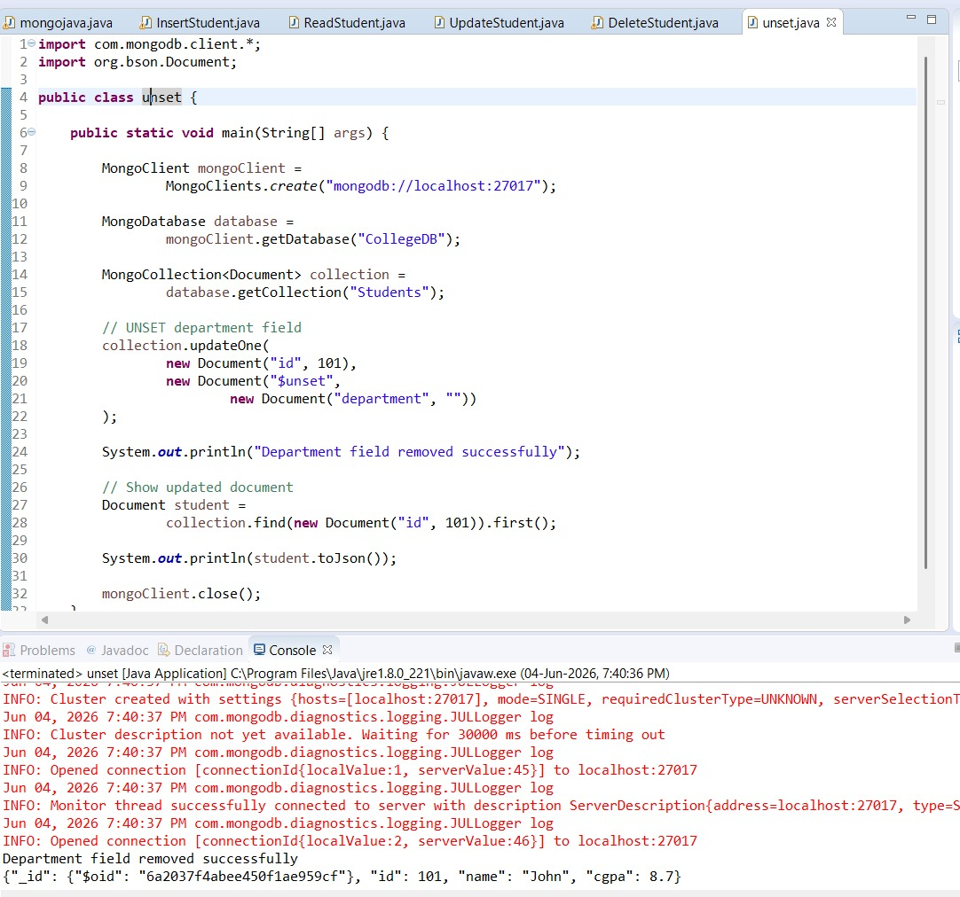

MONGODB CRUD OPERATIONS - RENAME OPERATOR
